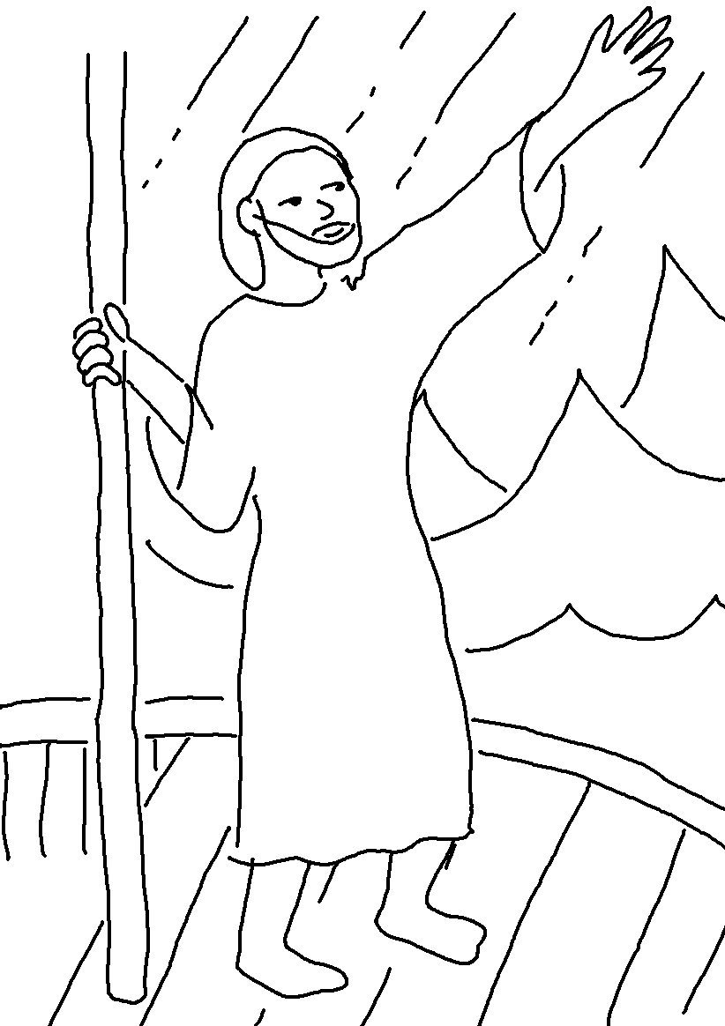

"Who is this man?"
they asked. "Even the _ _ _ _ _ and
_ _ _ _ _ obey him!"
Matthew 8:27_{NLT}

